The Luminaux Job – Notes

Intro

Captain Foxglove
Date: 8 Vigilance 4429 EJT/1342 O
Following the debacle with Division 2, Division 7 is given more than a month on “administrative hiatus” without pay. The month of Prosperity has passed, including a beautiful celebration of the Day of Mercy by local priests of Nevari. Another Day of Atonement is marked on the last day of the month with a sober ceremony in the office of the Justicar. The weather is hot, with that smoky scent hanging on the air that indicates the end of summer is coming. The moon is nearly full, making the evening the most pleasant part of the day.

Midway through the month of Vigilance, Division 7 is again assembled, and a very sober Captain Foxglove assesses her team.

“We have a delicate assignment for you – extremely delicate, in fact. We have further information regarding the remains of the angel you recovered in the Spire this spring. We believe the merchant Kaelys Tela still retains one legitimate piece of the fallen celestial, and has had it moved to the city of Luminaux.

Division 2 was able to track the Iron Rose caravan that moved the artifact, but the Guild moved too quickly and no opportunity presented itself to take it. Though Warden Blackdawn made an overture, Lady Tela was uninterested in selling it.

“Your job is to obtain it for us, by any means necessary. This is considered a matter of the highest national security.

“As you well know, Luminaux is one of the major cities of the Nation of Crescent. While there, you must exercise extreme discretion. As we have no legal authority to send soldiers into their territory, you will be very much on your own, a group of students and young aristocrats. Should you be captured or killed, the Tower will disavow any knowledge of your actions.

“You depart immediately. Wizard Roothollow will handle any logistical questions. Good luck and Godspeed.”

Wizard Roothollow:
“You are to report to the Aerodrome, where Captain Aerdane waits with the JIAS Thunderhead to take you to a secure landing spot a day’s travel outside of Luminaux. From there you will make your way to the City, to a tavern known as the [checks notes] Rusty Wing. We have arranged for Warden Summerstorm and Ambassador Templar to be performing there the evening of 10 Vigilance, so it will be extremely crowded, providing you ample cover for your movements. You have room reservations for the nights required, and a table reserved for the performance.

“Master Solinthas, a servant of Our Lady the Oracle, will meet you there during the concert. He is planning this operation, and will be your best source for further details.”
“Any questions?”

--time for questions--

“Move out!”

Solinthas
- Solinthas managed to track the item to the stronghold of House Kundarak, a dwarven Luminaux merchant family with strong ties to the Iron Rose Guild.
- House Kundarak invented banking. They have secure storage, and also deal in loans and investments
- He also “obtained” the keycharm to strongbox 237.
- When he tried to use it, he discovered that there was a password required to gain entrance to the vault area, which he lacked. It’s not a magical effect; it’s just security protocol.
- The compound is run by one Lord Brannick, and he keeps security tight. It’s protected by guards and magical effects, and bears roam the compound at night. And there’s a stone golem.
- I suggest you gather more information; I’ve started to attract attention by asking too many questions and need to lay low for a while.

Bank Notes

Renting a Strongbox or Vault
They are rented monthly based on size, from 10gp/month for something the size of a few books to 250gp/month for a 10x10 vault. If the PCs rent one, Chollak will give them a keycharm and accompany them to the vaults, explaining pertinent security features along the way.

Lady Tela’s Strongbox
The security password is Devaskus, the name of the childhood pet of her retainer Delphis (the dude mugged by Solinthas). Short of powerful divination magic, the only way the PCs can learn of this is in the ledger Chollak keeps in the main security office. The strongbox is number 237. There are additional traps on the inner box (see map details)

Applying for a Job
Dwarves and gnomes only, must make diplomacy check to convince Lord Brannick. His attitude starts at indifferent. Dwarves get a +2 to Diplomacy checks. If his attitude slips to unfriendly, visitors are escorted out. Will offer a job if attitude changes to helpful (DC 30 or two at DC 15 and 20, in order). Job offer comes with zone of truth interview; declining interview automatically drops his attitude to hostile and he has the applicant escorted out and the guards on heightened alert for a week.

Encounters

Daytime, Outside

Guards
6 on the walls - 2 pairs on the wall, opposite each other, counterclockwise patrol, 20'/round. A full circuit takes 2:24 (24 rounds), therefore there are guards passing any given spot every 1:12 (12 rounds). Third pair in gatehouse.

Daytime, Ground Floor

Guards
2 in guard station, 2 in Main Security Office, 2 in lobby area

Lord Brannick, Rurin d’Sivis, Lady Thorina, Flindal d’Sivis, Chollak d‘Kundarak
In their offices

The Guardian
In front lobby, mostly passive

Daytime, Residential Level

Guards
3 in the dining area, 3 in the barracks area

Daytime, Vault Level

Guards
1 at each sentry station, 1 in Security Office

Invisible Stalker
In strongbox area, passive

Nighttime, Outside

Guards
6 on the walls - 2 pairs on the wall, opposite each other, counterclockwise patrol, 20'/round. A full circuit takes 2:24 (24 rounds), therefore there are guards passing any given spot every 1:12 (12 rounds). Third pair in gatehouse.

Bears
Wandering the grounds. 15% chance one will see anyone on the grounds per round; will take 2 rounds to charge and bellow, rest will arrive 1d4 rounds later.

Nighttime, Ground Floor

Lady Thorina, Flindal d’Sivis
In her office

The Guardian
In lobby, attacks on sight, will not leave lobby.

Nighttime, Residential Level

Guards
2 in the dining area, 4 in the barracks area

Lord Brannick
Asleep in his quarters.

Rurin d’Sivis
Playing cards with guards in dining area

Nighttime, Vault Level

Guards, Vault Level
6 in Vault Security Office, playing dice.
-5 LISTEN, will have to take round to stand and arm themselves

Invisible Stalker
In strongbox area, will attack on sight.

Guards

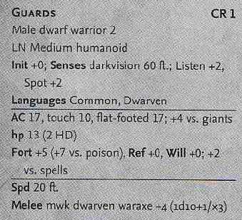
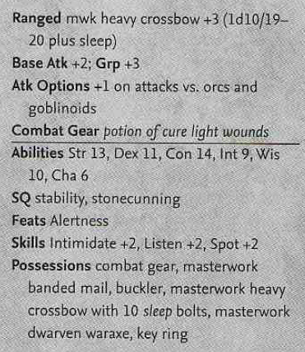

Magebred Black Bears
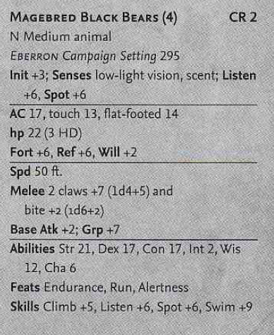

The Guardian
 | Animated Object, Large
 | Large Construct
Hit Dice: | 4d10+30 (52 hp)
Hardness | 8
Initiative: | +0
Speed: | 30 ft. legs
Armor Class: | 14 (–1 size, +5 natural), touch 9, flat-footed 14
Base Attack/Grapple: | +3/+10
Attack: | Slam +5 melee (1d8+4)
Full Attack: | Slam +5 melee (1d8+4)
Space/Reach: | 10 ft./10 ft. (tall)
Special Attacks: | See text
Special Qualities: | Construct traits, darkvision 60 ft., low-light vision; also see text
Saves: | Fort +1, Ref +1, Will –4
Abilities: | Str 16, Dex 10, Con —, Int —, Wis 1, Cha 1
Skills: | —

Betrayer (Rurin/Flindal/Chollak)
Sense motive +1 to determine agents’ intentions.

“Alright, the compound seems pretty standard from the outside – high walls, guards, clear space inside and outside the walls. The walls are 5 feet thick, 10 feet high, and extend down into the earth to merge with the bedrock. There’s one functional gate.

“The main house itself is just as well built, with iron-reinforced walls, sovereign glue-sealed windows and skylights.

“There are 30 guards, and they patrol in shifts of six. At any given time, one group is on the wall, one on the main floor, one at the vault guard station, and one on call in the residential area. The final group is on free time, but can be recalled in an hour or so. They rotate every six hours.

“Pretty standard stuff so far, but there’s some twists. At night, the outside grounds are patrolled by bears – four of them. They’re specially bred for this duty, too, and very fast.

“There’s a warding spell in effect over the whole compound, which will kill you if you don’t know the password. The password is, very originally, Kundarak.

“There’s also an invisible stalker laired in the vault levels; it scares the guards.

“Finally, there are the vaults themselves. Each strongbox has an individual keycharm, which is only one half of the combination required to open the box. You must also have one of the master keys, of which there’s only two – one in the vault security office and one carried by Lord Brannick.

“Your best bet is to stage the raid at night, when most of the staff has either left or will be asleep. I can arrange for the skylight in my office to be opened, and my door unlocked, on a specific night. I will also stand down my office guardians. Beyond that, you’re on your own; I plan on being quite visible in the dining hall when this all goes down.”

Notes:
He can sketch out a map of the facility if required; will not include all details such as secret doors.

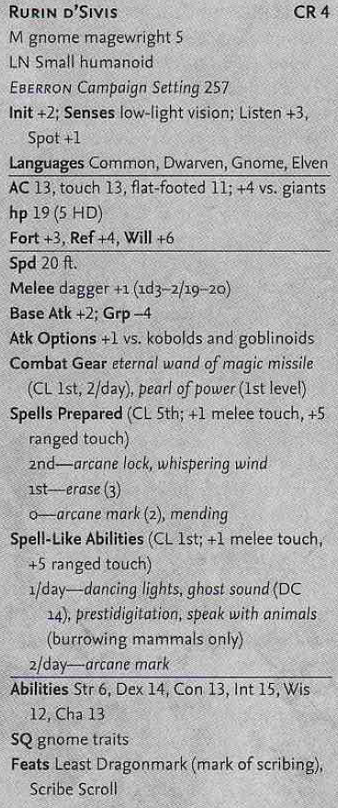
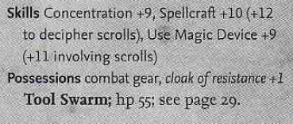

Tool Swarm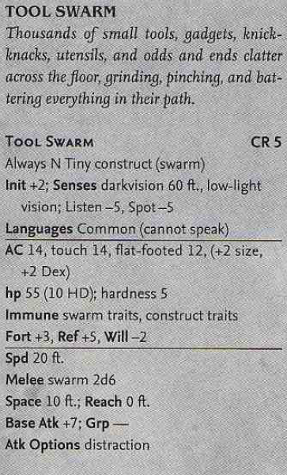
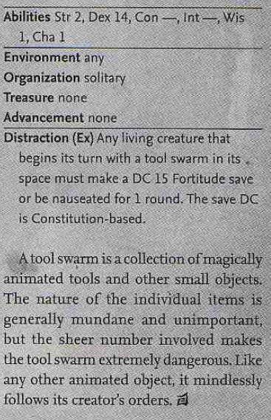Nauseated creatures are unable to attack, cast spells, concentrate on spells, or do anything else requiring attention. The only action such a character can take is a single move action per turn.

Invisible Stalker
 | Large Elemental (Air, Extraplanar)
Hit Dice: | 8d8+16 (52 hp)
Initiative: | +8
Speed: | 30 ft. (6 squares), fly 30 ft. (perfect)
Armor Class: | 17 (–1 size, +4 Dex, +4 natural), touch 13, flat-footed 13
Base Attack/Grapple: | +6/+14
Attack: | Slam +10 melee (2d6+4)
Full Attack: | 2 slams +10 melee (2d6+4)
Space/Reach: | 10 ft./10 ft.
Special Qualities: | Darkvision 60 ft., elemental traits, natural invisibility, improved tracking
Saves: | Fort +4, Ref +10, Will +4
Abilities: | Str 18, Dex 19, Con 14, Int 14, Wis 15, Cha 11
Skills: | Listen +13, Move Silently +15, Search +13, Spot +13, Survival +2 (+4 following tracks)
Feats: | Combat Reflexes, Improved Initiative, Weapon Focus (slam)
Invisible stalkers have an amorphous form. A see invisibility spell shows only a dim outline of a cloud, while a true seeing spell reveals a roiling cloud of vapor.

COMBAT
An invisible stalker attacks by using the air itself Natural Invisibility (Su): This ability is constant, allowing a stalker to remain invisible even when attacking. This ability is inherent and not subject to the invisibility purge spell.
Improved Tracking (Ex): An invisible stalker is a consummate tracker and makes Spot checks instead of the usual Survival checks to trace a creature’s passage.

Lord Brannick